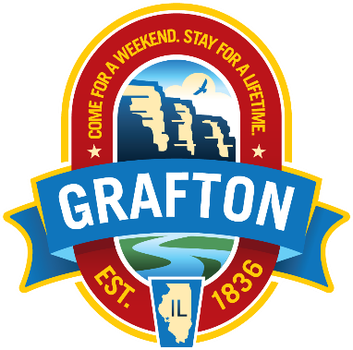

GRAFTON - A Real American River Town

NATURE’S SCENIC BEAUTY

- Runs the length of the National Scenic Byway along Route 100
- Nestled below majestic limestone bluffs at the confluence of the Mississippi and Illinois Rivers
- The drive through Grafton, Illinois has been named one of the 10 greatest drives in the nation
- Referred to as the “Key West of the Midwest”
- Vantage points to view the best sunsets and sunrises
- Flyway for wintering American Eagles and summer white Pelicans
- Home to a wide variety of water birds as well as typical Midwest birds

HISTORIC GRAFTON
- Grafton was platted in 1836 and is the oldest community in Jersey County
- A Historical Walking Guide is available. Local guides can be provided for groups.
- Information regarding the founding of Grafton, Quarries, the powder mill, the War of 1812, the Dinky railbus, quarries, boat building, fishing and hunting are on display at the local history museum at the Visitor Center
- Buildings constructed of local magnesia limestone are scattered throughout town including St. Patrick’s Catholic Church.
- Grafton received 2 Governor Home Town Awards for quality of life

LODGING
- Lodging in 26+ guest houses are available within City limits
- Guest houses for groups with 6-14 people available for reunions and larger groups
- Historic Ruebel Hotel offers 22 rooms
- Aeries Resort offers 55 rooms, 16 with 2 queen beds
- Handicap accessible rooms available

EATING AND DRINKING
- Several establishments providing a wide variety of food and drink are located along Main Street. Most have a river view.
- Several wineries
- Craft microbrewery
- Locally produced award wines
- Confectionaries & Ice Cream

SHOPPING
- Several unique shops offering:
  - Locally produced art
  - Hand crafted unique pieces
  - Wood sculptures
  - Pottery
  - Jewelry
  - Lamps
  - Tables
  - Home décor
  - Outdoor décor
- Grafton Souvenirs

SPECIAL ATTRACTIONS
- Grafton Sky Tour
- Raging Rivers Water Park
- Hakuna Matata Riverboat Cruise
- Grafton Zip Line
- Boat Rentals
- 5 Star Marina
- Horse-Back Riding
- Golf – Lockhaven Golf Club
- Ice Skating Rink (November thru March)
- Light House Park with picnic tables
- Grove Memorial Park with pavilion and picnic tables
- Best View in the Midwest

Contact us:
www.enjoygrafton.com
www.graftonILchamber.com
graftonchamber@gmail.com

